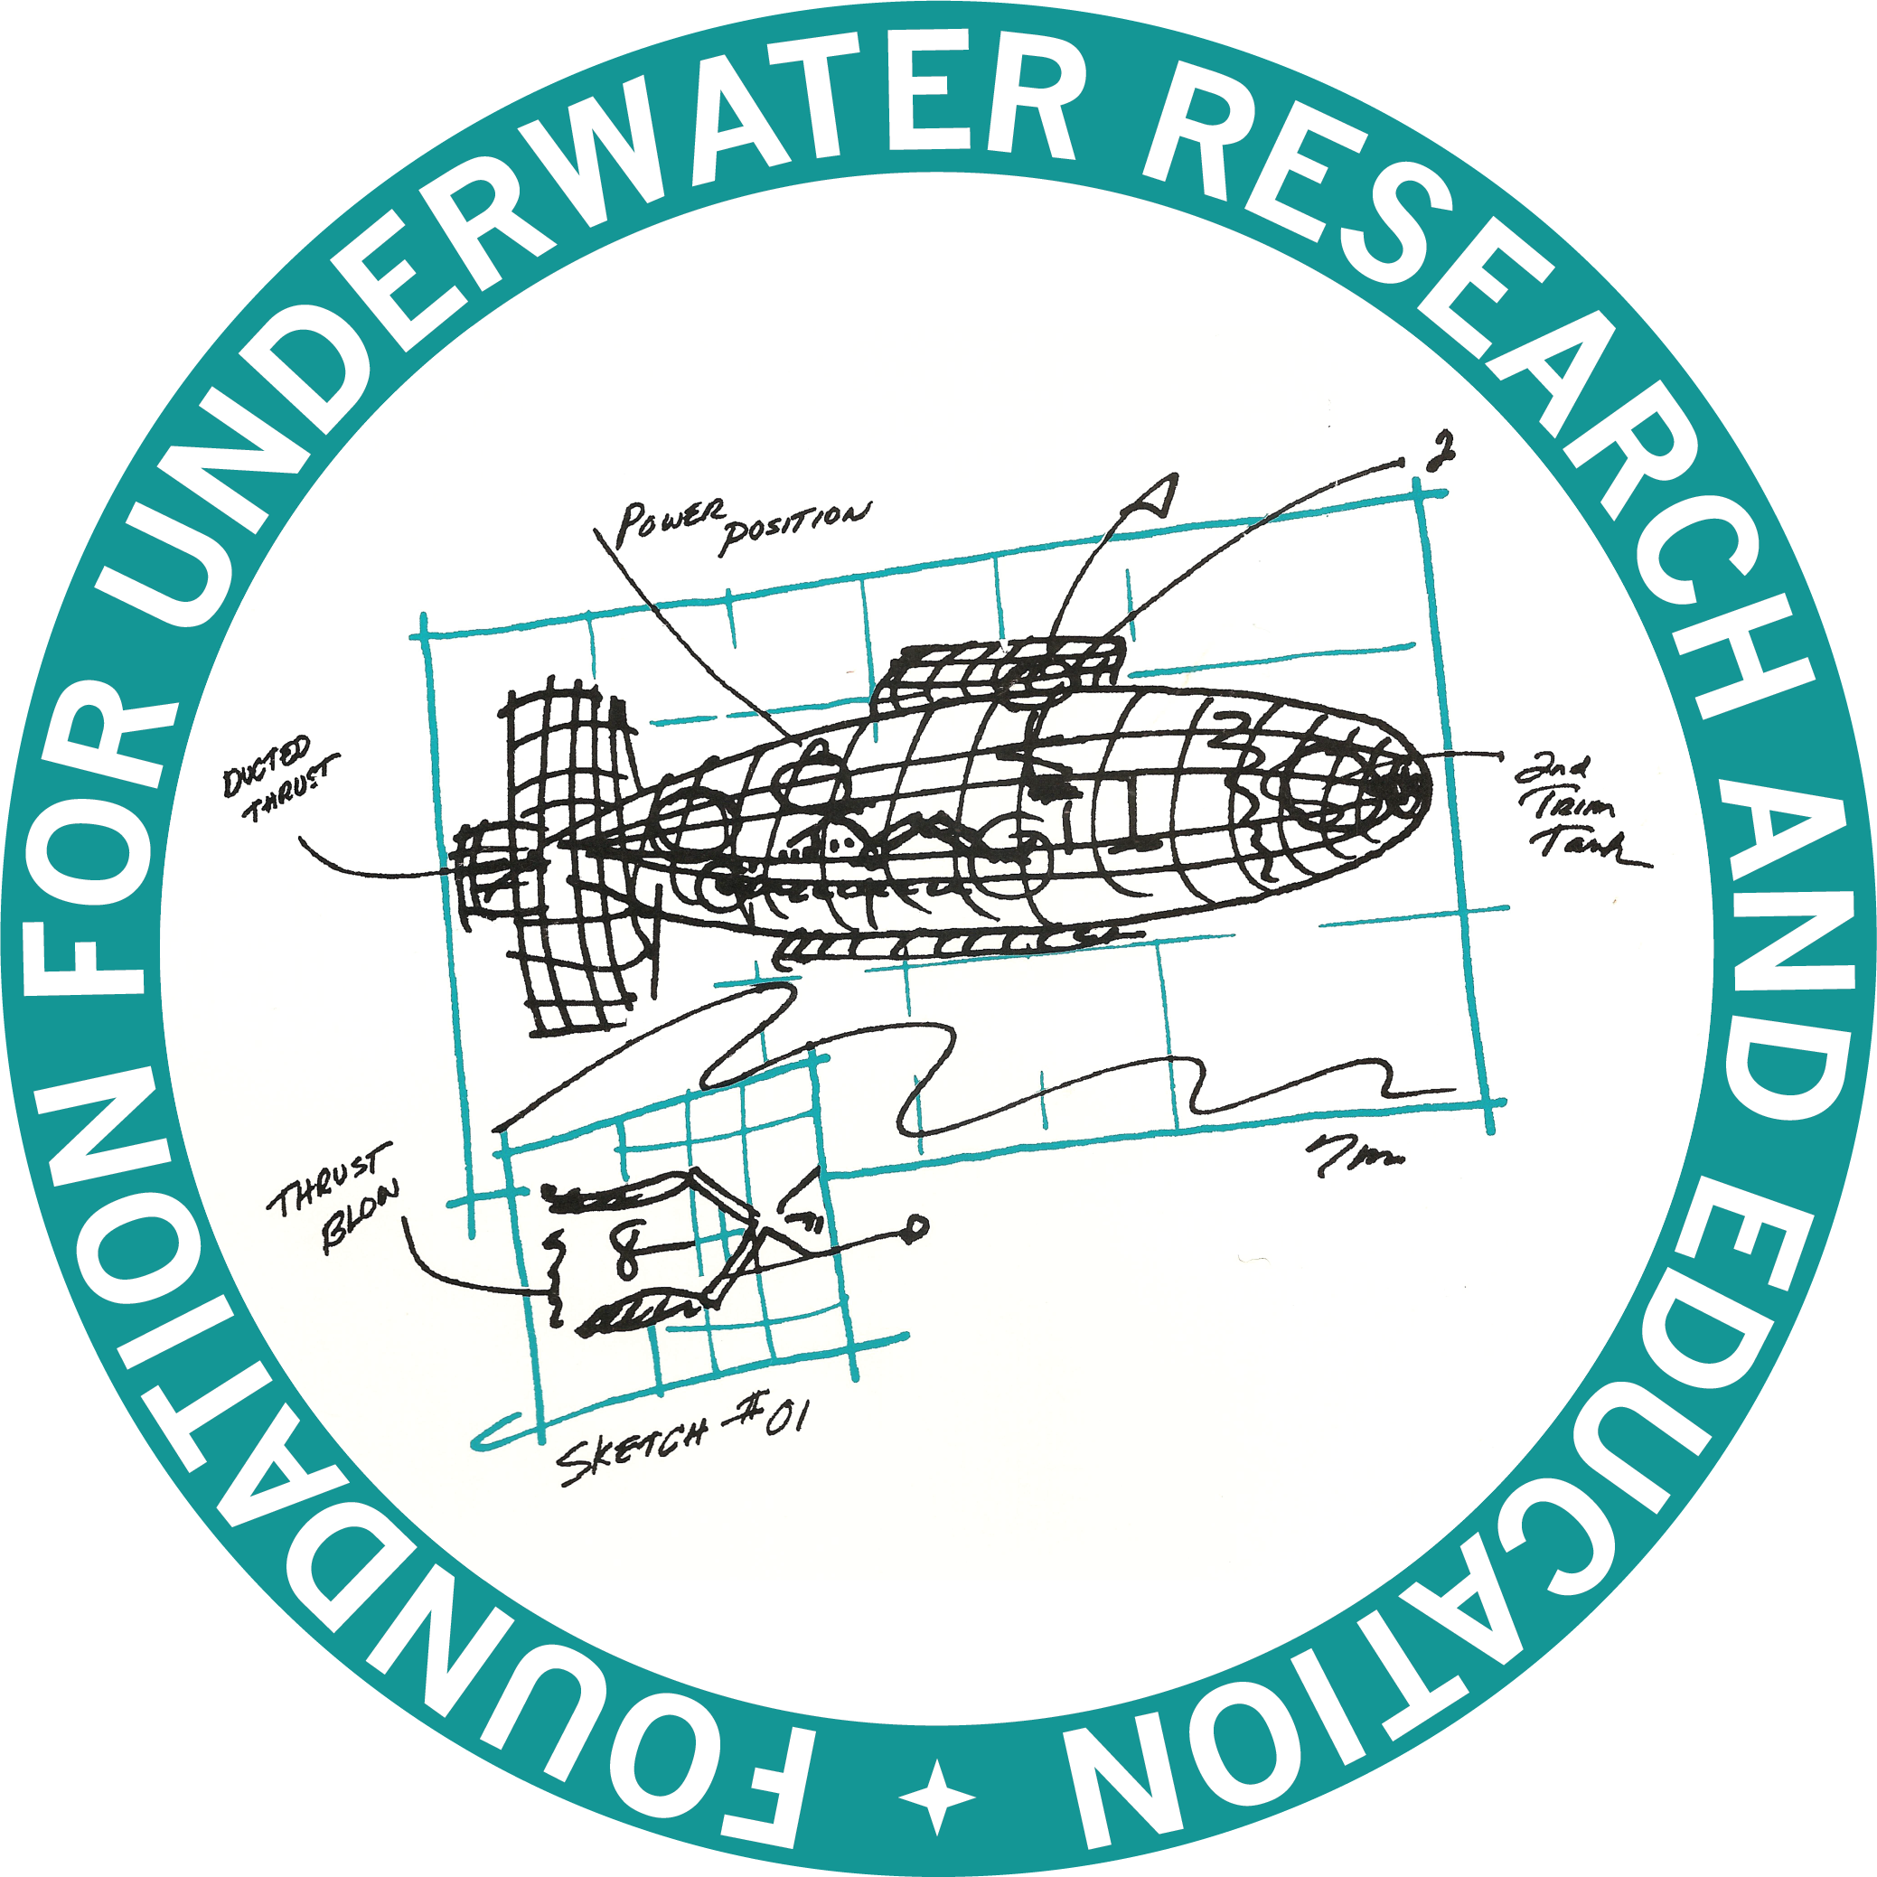
Foundation for Underwater Research and Education

2022 Scholarship Application

Purpose: To inspire students to delve into broad areas of underwater sciences, engineering and technologies, to encourage pursuit of academic studies and careers in the sciences and engineering, and to support the conduct of scientific, technical, engineering and math related exercises that enhances students’ knowledge.
Eligibility: Individuals who are graduating high school students or college students who have displayed an interest in human-powered submarining and related activities and are pursuing degrees related to the marine sciences, engineering, or related fields at an accredited institution. This scholarship is intended to assist in postsecondary education expenses.
Award Evaluation and Criteria:
- Response to essays
  - Why do the underwater sciences interest you?
  - Who or what inspires you?
  - What is your history with human-powered submarines?
  - Why are you the best candidate for this scholarship?
- Three Letters of Recommendation (two professional and one personal)
- Scholastic achievement
- Community involvement
- Extra-curricular activities
Award Amount: At least one annual award of $1500 will be made, however the amount and number of awards can vary annually based on the number of qualified candidates and availability of funds.
Awardee Requirements:
- Submission of a written report (no more than two pages) summarizing the benefit of the award and how it was used within 1 year of receipt.
Foundation for Underwater Research and Education
2022 Scholarship Application

SECTION 1: APPLICANT INFORMATION
- Name (Last, First, Middle):

- Address:

- Phone:

- Email address:

- Date of Birth (month/day/year):

- Have you previously received a scholarship from FURE? If “yes”, please provide detailed information

- Please provide the name and location of your most recently attended scholastic institution.

- Please provide a transcript that shows your last three years of academic performance. This transcript may be from a high school, college(s) or a combination of the two. Please ensure that GPA and the GPA scale are provided on the transcript.

- Please list your paid employment experience (employer, position, and dates of employment).

- Please describe any volunteer or extracurricular activities that you have actively participated in over the last three years.

- Please list any awards or special recognitions you have received in the past 3 years. (Include awarding organization, award title, date awarded, and reason for the award).

Signature________________________________________ Date: _______________
Foundation for Underwater Research and Education
2022 Scholarship Application

Section 2: ESSAY QUESTIONS (Limit response to this page, please use nothing smaller than 12 font pitch if typed)
Essay 1: Why do the underwater sciences / engineering / technologies interest you?

Foundation for Underwater Research and Education
2022 Scholarship Application

Section 2: ESSAY QUESTIONS (Limit to this page)
Essay 2: Who or what inspires you? (Limit response to this page, please use nothing smaller than 12 font pitch if typed)

Foundation for Underwater Research and Education
2022 Scholarship Application

Section 2: ESSAY QUESTIONS (Limit responses to this page, please use nothing smaller than 12 font pitch if typed)
Essay 3: What is your history with human-powered submarines?

Foundation for Underwater Research and Education
2022 Scholarship Application

Section 2: ESSAY QUESTIONS (Limit response to this page, please use nothing smaller than 12 font pitch if typed)
Essay 4: Why are you the best candidate for this Scholarship?
Foundation for Underwater Research and Education
2022 Scholarship Application

Section 3: APPLICATION INFORMATION
ELIGIBILITY REQUIREMENTS
Applicants must have successfully graduated or will graduate in 2022 from a secondary (high school) educational institution and will be or are enrolled in a postsecondary institution. Prior participation in a human-powered submarine event is not required.
APPLICATION PERIOD
Applications are available on FURE’s website (internationalsubmarineraces.org). All materials, including official transcripts and letters of recommendation, must be received postmarked no later than May 4, 2022.
An anonymous committee, reporting to the FURE Board of Directors, will carefully review and evaluate all complete and timely applications. Award notifications will be sent beginning on June 1, 2022.
APPLICATION CONTENT
- This completed Application package, including signature on Page 2
- Official transcripts from all secondary schools for grades 10 -12 (minimum)
- Official transcripts for all postsecondary schools (if any)
- 1st letter of recommendation (professional). Emailed from recommender to address below
- 2nd letter of recommendation (professional). Emailed from recommender to address below
- 3rd letter of recommendation (personal). Emailed from recommender to address below

ONLY COMPLETE APPLICATIONS WILL BE CONSIDERED FOR AWARD

APPLICATION SUBMISSION
Submit this application package and any supporting documentation via email to:
FURE.Vicepresident@internationalsubmarineraces.org
Please have the recommendations associated with your application emailed by the recommender to:
FURE.Vicepresident@internationalsubmarineraces.org

Alternately, completed scholarship applications and or recommendations may be mailed to:
- US mail to: FURE Scholarship Application
c/o Daniel Dozier
23490 Maddox Rd
Chaptico, MD 20621

- Please send an e-mail to alert that you have sent in an application package via US Mail, so that the FURE Vice President can confirm upon receipt. Send e-mail to FURE.VicePresident@internationalsubmarineraces.org

